Social Studies 8 Mrs. Ingold
Topic : Aim to Claim: Peter Jennings presents “The Century” – HAPPY DAZE THE 1950’S Parts 1-3
Name:_______________________________________________________________________________________________
Listen and take notes on the following video excerpt from Peter Jennings “ The Century”. Use the back if necessary. Then, make a claim and provide evidence on the statement that follows.
AIM: How did the United States try to continue to live up to its promise and potential in the “Happy Daze” of the 1950’s? ( Be a “SPECu laToR” by choosing 3 of the following below: )
SOCIAL POLITICAL ECONOMIC CULTURAL TECHNOLOGICAL RELIGIOUS
EVIDENCE:

EXIT TICKET ANALYSIS: Peter Jennings presents “The Century”
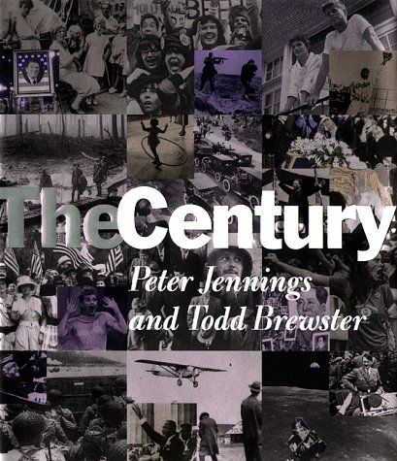

NAME:_________________________________________________________________________
DIRECTIONS: Complete the following claim statement based on the information from the video excerpt and your knowledge of social studies. Then, provide two specific pieces of evidence to support the claim below.
CLAIM: The United States has lived up to its promise _________________________________ and ________________________________________
( Choose two ASPECTS below to be supported by specific details above)
Cite 2 pieces of evidence below to support the above claim.
EVIDENCE SUBMISSION:

