Social Studies 8 Mrs. Ingold
Topic: Perspective and Point of View in the Real World Date:____________

Name:______________________________________________________________________________

Directions: You will be conducting an investigation on certain aspects of our modern rights and civil liberties. Watch and listen to the following perspectives and/or points of view and take detailed notes on each issue in the spaces provided. Then, analyze the task-based inquiry question using the evidence collected during your investigation to make a final determination on the issue.

Compelling Question: How are perspective and point of view defined by real world situations?
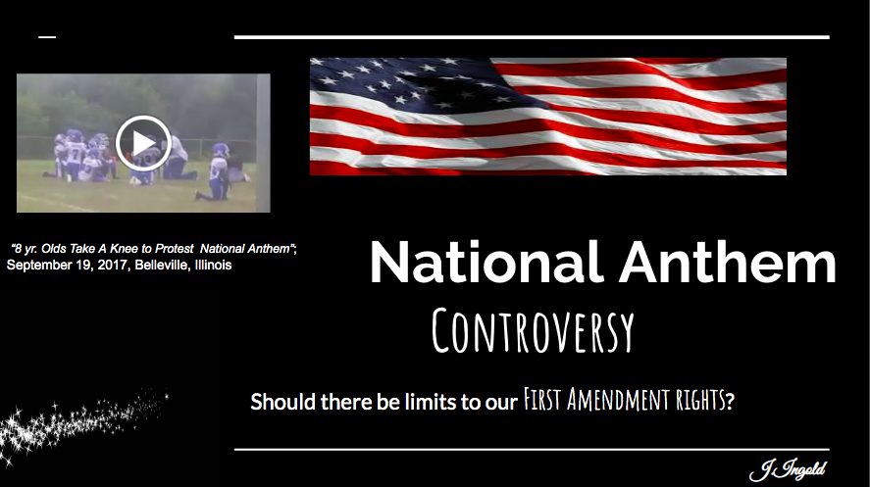
Exhibit Log Sheet

EXHIBIT A: The National Anthem Controversy
“ 8 YR. OLD’S “TAKE A KNEE to Protest National Anthem”
HYPOTHESIS: Should there be limits to Our First Amendment Rights?

YES NO NOT SURE

NOTES:

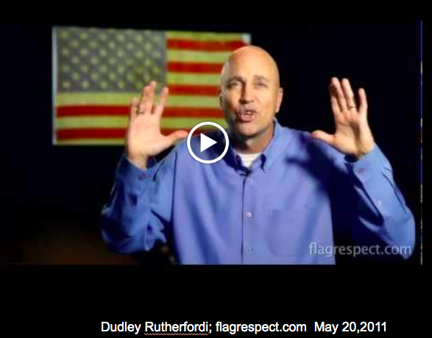

EXHIBIT B: “ The Accurate Story Behind the Star Spangled Banner”

NOTES:

ANALYZE: Weighing the EVIDENCE:

DIRECTIONS: Answer the questions below and you analyze and consider the evidence from each of the sources presented.

- Who or what are the SOURCES of information?

- Are the sources more PERSPECTIVE or POINT OF VIEW?

FOX NEWS CLIP:

FLAGRESPECT.ORG DOCUMENTARY:

- Do either or both contain BIAS? Give an example.

- Which source do you think is the most RELIABLE?
Why?

* RELIABILITY = consistent in good quality or performance; able to be completely trustworthy

CLOSING STATEMENT AND CONCLUSION: ( circle your choice )

Based on the information collected from our study of “The National Anthem Controversy” it can be determined that Americans first amendment rights SHOULD or SHOULD NOT be limited .

Cite two of the BEST pieces of evidence to support the above claim below.

EVIDENCE:

Social Studies 8 Mrs. Ingold
Topic: Aim to Claim: P vs. POV in the Real World

Name: ______________________________________________________________________________

The National Anthem Controversy

CLOSING STATEMENT AND CONCLUSION: ( circle your choice )

Based on the information collected from our study of “The National Anthem Controversy” it can be determined that Americans first amendment rights SHOULD or SHOULD NOT be limited .

Cite two of the BEST pieces of evidence to support the above claim below.

EVIDENCE:

