Enduring Issues Reference Guide

Social Studies 8 Mrs. Ingold

Enduring by definition means “long lasting” … making an Enduring Issue is an issue that exists and extends across time and place, even extending into subcategories of human existence, such as race, culture and/or religious affiliation. Enduring Issues are important ideas and/or circumstances that people often struggle with as new situations concerning them arise. They are issues that many societies have attempted to address with varying degrees of success. Often, these situations are on-going into present or modern time.
.
Enduring issues are often identified by their “nested issues”, meaning that there are several identifying indicators that create a common theme among the items that are being observed. (documents)
ENDURING ISSUES COMMON THEMES
REFERENCE TABLE
CONFLICT | POWER | HUMAN IMPACT ON THE ENVIRONMENT
HUMAN RIGHTS VIOLATIONS | SECURITY | IMPACT OF ENVIRONMENT ON HUMANS
SCARCITY | POPULATION GROWTH | TENSIONS BETWEEN TRADITIONAL AND MODERN CULTURE
IMPACT OF TRADE | IMPACT OF CULTURAL DIFFUSION | IMPACT OF TECHNOLOGY
IMPACT OF INDUSTRIALIZATION | IMPACT OF URBANIZTION | IMPACT OF NATIONALISM
IMPACT OF IMPERIALISM | IMPACT OF COLONIZATION | IMPACT OF EMPIRE BUILDING
IMPACT OF DECOLONIZATION | IMPACT OF MIGRATION | IMPACT OF GLOBALIZATION
EQUITY ISSUES/LACK OF ACCESS OF EQUALITY | IMPACT OF COOPERATION/MUTUAL PROBLEM SOLVING | YOUR OWN IDENTIFICATION
Social Studies 8 Mrs. Ingold
Enduring Issues 3
Topic: Enduring Issues Skills Practice Period #:_________
Name:_________________________________________________________________________________________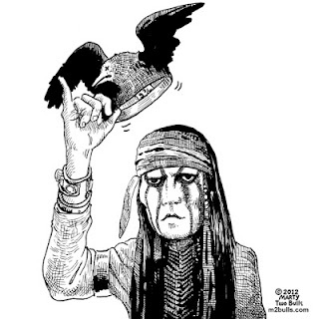
Native Americans Enduring Issues Essay

DIRECTIONS:
In your essay, you will be asked to complete the following tasks:
- • Identify and define an enduring issue raised by this set of documents.
- • Using your knowledge of Social Studies and evidence from the documents, argue why the issue you selected is significant and how it has endured across time. Be sure to :
- • Identify the issue on a historically accurate interpretation of two to three documents using evidence from at least three two documents
- • Argue that this is a significant issue that has endured by showing:
o How the issue has affected people or been affected by people
o How the issue has continued to be an issue or changed over time
• Include outside information from your knowledge of social studies and evidence from the documents.
Read

Identify Key Words

Make Connections
Document 1:
A Drawing of an Iroquois Longhouse
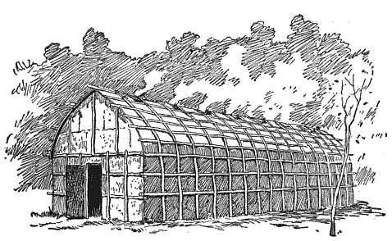
Source: Unknown
What is the main cause and/or Enduring Issues theme identifiable by the photograph above above?

Which of the following Enduring Issues base categories best identifies this concern?
( circle all that apply)

Social Political Economic Religious Geographical

Related Information Notes: ( Come from your own background knowledge of topic)

Document 2:
Read

Identify Key Words

Make Connections

A Bison Hunt
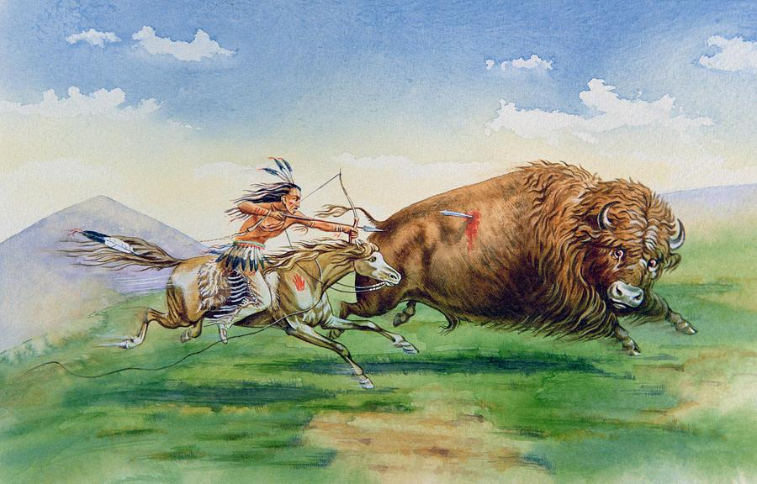
Source: George Catlin, A Bison Hunt: American Artist, Painter & Settler, 1830

What is the main cause and/or Enduring Issues theme identifiable by the photograph above above?

Which of the following Enduring Issues base categories best identifies this concern?
( circle all that apply)

Social Political Economic Religious Geographical

Develop a minimum 1-3 sentence argument about how the author’s bias might have been influenced by your cited Enduring Issues theme.

Document #3:
Read Identify Key Words
Make Connections

Excerpt: “Peace and Friendship” Treaty Part A
THE parties being desirous of establishing permanent peace and friendship between the United States and the said Creek Nation, and the citizens and members thereof, and to remove the causes of war by ascertaining their limits, and making other necessary, just and friendly arrangements: The President of the United States, by Henry Knox, Secretary for the Department of War, whom he hath constituted with full powers for these purposes, by and with the advice and consent of the Senate of the United States, and the Creek Nation, by the undersigned Kings, Chiefs and Warriors, representing the said nation have agreed to the following articles.

ARTICLE 1.
There shall be perpetual peace and friendship between all the citizens of the United States of America, and all the individuals, towns and tribes of the Upper, Middle and Lower Creeks and Semanolies composing the Creek nation of Indians.

ARTICLE 2.
The undersigned Kings, Chiefs and Warriors, for themselves and all parts of the Creek Nation within the limits of the United States, do acknowledge themselves, and the said parts of the Creek nation, to be under the protection of the United States of America, and of no other sovereign whosoever; and they also stipulate that the said Creek Nation will not hold any treaty with an individual State, or with individuals of any State. …
Source: Henry Knox, Secretary of War to the POTUS, The tribal leaders of the Creek Nation
“ Peace and Friendship” Treaty between the United States of America and the Creek Nation, August 7, 1790

What is the main cause and/or Enduring Issues theme identifiable by the photograph above above?

Which of the following Enduring Issues base categories best identifies this concern?
( circle all that apply)

Social Political Economic Religious Geographical

Develop a minimum 1-3 sentence argument about how the author’s position/point of view in this treaty may have affected or influenced your cited Enduring Issues theme.

Document #4:
Read

Identify Key Words

Make Connections

Excerpt: “Peace and Friendship” Treaty Part B

ARTICLE 3.
The Creek Nation shall deliver as soon as practicable to the commanding officer of the troops of the United States, stationed at the Rock-Landing on the Oconee river, all citizens of the United States, white inhabitants or negroes, who are now prisoners in any part of the said nation. And if any such prisoners or negroes should not be so delivered, on or before the first day of June ensuing, the governor of Georgia may empower three persons to repair to the said nation, in order to claim and receive such prisoners and negroes.

ARTICLE 4.
The boundary between the citizens of the United States and the Creek Nation is, and shall be, from where the old line strikes the river Savannah; thence up the said river to a place on the most northern branch of the same, commonly called the Keowee, where a north east line to be drawn from the top of the Occunna mountain shall intersect; thence along the said line in a south-west direction to Tugelo river; thence to the top of the Currahee mountain; thence to the head or source of the main south branch of the Oconee river, called the Appalachee; thence down the middle of the said main south branch and river Oconee, to its confluence with the Oakmulgee, which form the river Altamaha; and thence down the middle of the said Altamaha to the old line on the said river, and thence along the said old line to the river St. Mary's.

Source: Henry Knox, Secretary of War to the POTUS, The tribal leaders of the Creek Nation
“ Peace and Friendship” Treaty between the United States of America and the Creek Nation, August 7, 1790

What is the main cause and/or Enduring Issues theme identifiable by the photograph above above?

Which of the following Enduring Issues base categories best identifies this concern?
( circle all that apply)

Social Political Economic Religious Geographical

Develop a minimum 1-3 sentence argument about how the author’s position/point of view in this treaty may have affected or influenced your cited Enduring Issues theme.
CONSIDER: Has his position become more or less biased as the treaties articles have continued to be written?

Document #5:
Read

Identify Key Words

Make Connections

Excerpt: “Long Hair” Letter from Commissioner of Indian Affairs to Round Valley, California
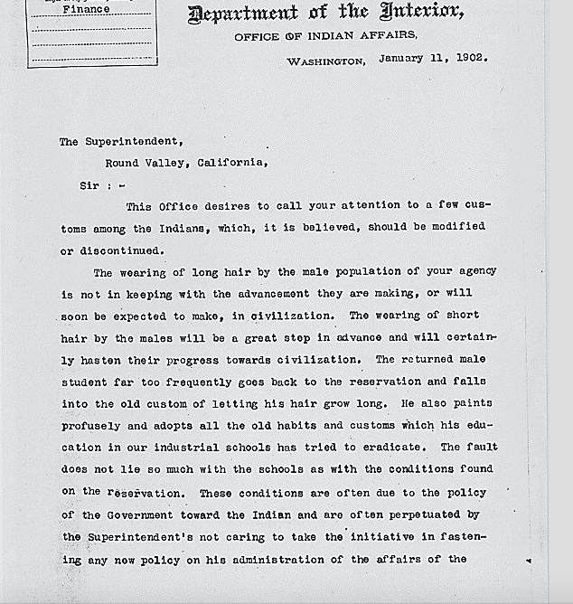
Source: William A. Jones, Commissioner of Department of Indian Affairs January 11, 1802

Excerpt: “Long Hair” Letter from Commissioner of Indian Affairs to Round Valley, California
Read

Identify Key Words

Make Connections

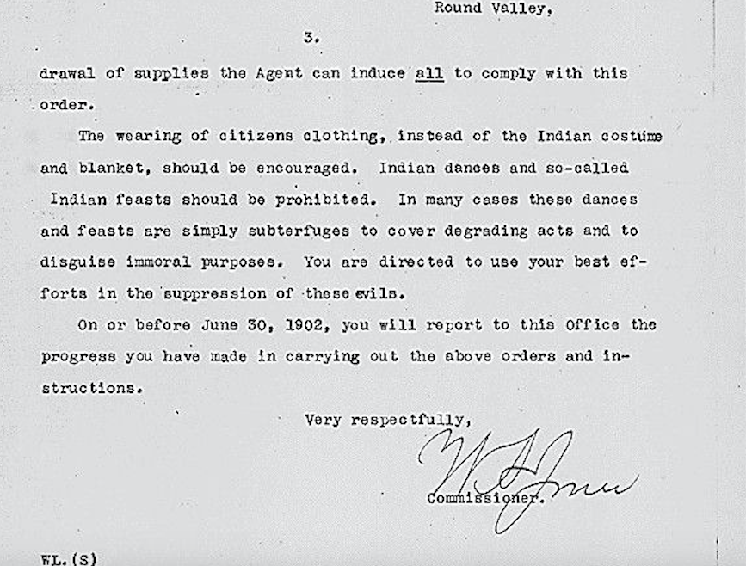
Source: Commissioner William A. Jones, Department of Indian Affairs, January 11, 1802

What is the main cause and/or Enduring Issues theme identifiable by the photograph above above?

Which of the following Enduring Issues base categories best identifies this concern?
( circle all that apply)

Social Political Economic Religious Geographical

Develop a minimum 1-3 sentence argument about how the author’s position/point of view in his speeches affected your cited Enduring Issues theme.
CONSIDER: Has his position become more or less biased as the treaties articles have continued to be written?

Native Americans Enduring Issues Essay

An Enduring Issue is an issue that exists across time. It is one that many societies have attempted to address with varying degrees of success

In your essay, you will be asked to complete the following tasks:
- • Identify and define an enduring issue raised by this set of documents.
- • Using your knowledge of Social Studies and evidence from the documents, argue why the issue you selected is significant and how it has endured across time.

- Be sure to :
- • Identify the issue on a historically accurate interpretation of two to three documents using evidence from at least three two documents
- • Argue that this is a significant issue that has endured by showing:
o How the issue has affected people or been affected by people
o How the issue has continued to be an issue or changed over time
• Include outside information from your knowledge of social studies and evidence from the documents.

Guidelines:
*Read each task idea to gain a full understanding of what is being asked
*Identify (by underlining or highlighting) key words and terms in the task
*Make connections between the tasks being asked and the documents provided

