Social Studies 8 Mrs. Ingold
Topic : Aim to Claim: RECONSTRUCTION/ “An Overview”
Name:_______________________________________________________________________________________________
Listen and take notes on the following video excerpt from “ Reconstruction: An Overview”. Use the back if necessary. Then, make a claim and provide evidence on the statement that follows.
AIM: What aspects of change was the greatest barrier to the Reconstruction of the United States after the end of the Civil War ? ( circle two)
SOCIAL POLITICAL CULTURAL RELIGIOUS GEOGRAPHICAL
PART 1 EVIDENCE: Reconstruction An Overview

PART 2 EVIDENCE: Military Reconstruction Act History & Summary
EXIT TICKET ANALYSIS: RECONSTRUCTION / “An Overview”
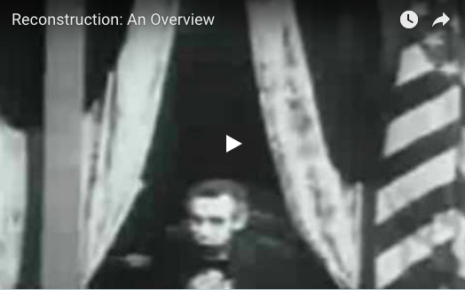
NAME:_________________________________________________________________________
DIRECTIONS: Complete the following claim statement based on the information from the video excerpt and your knowledge of social studies. Then, provide two specific pieces of evidence to support the claim below.
CLAIM: _________________________________ and/or ________________________________________ were the greatest barriers to the Reconstruction of the United States after the end of the Civil War.
( Choose two)
SOCIAL POLITICAL CULTURAL RELIGIOUS GEOGRAPHICAL
Cite 4 pieces of evidence below to support the above claim.
COLLECTIVE EVIDENCE SUBMISSION:

